**Project Explanation / Implementation Details**

Delve is a combination of Personalized Itinerary Generator integrated with social media. Any user can plan a perfect trip by just giving their requirements along with some basic information and will get the best possible itinerary in-terms of traveling, accommodations, Point of Interest[POI], and most importantly best deals. Social Media benefits in increasing the quality of trip by providing an opportunity to communicate with people near you and also allows you to get a gist of the location you will be visiting.

This Project is Developed using Redux Implementation of MERN stack.

The Project is Basically divided into 3 modules namely: Social Media, Itinerary Generator & Best Deals.

As mentioned above Delve is Implemented in the MERN stack (MongoDB, Express.js, React.js, Node.js) Coupled with a Machine Learning Model for Itinerary Generator.

Let’s See Implementation of Each of these Modules in detail.

1. **Social Media**: It contains Features like Posting Reviews, Like, Comment, User Authentication with JWT & GoogleOAuth, and also Privileges Management in the Redux Store.

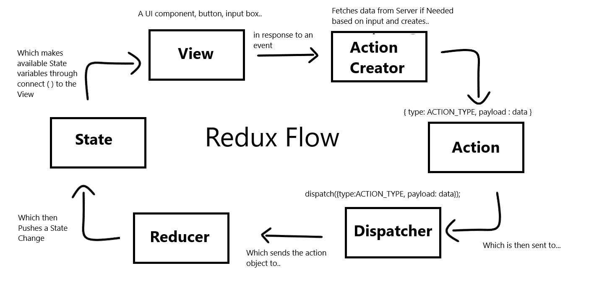

**JWT Authentication**

JWT authentication is a token-based stateless authentication mechanism. It is popularly used as a client-side-based stateless session, this means the server doesn’t have to completely rely on a data store (or) database to save session information.

JWTs can be encrypted, but they are typically encoded & signed. We will be focusing on Signed JWTs. The purpose of Signed JWT is not to hide the data but to ensure the authenticity of the data. And that is why it’s highly recommended to use HTTPS with Signed JWTs.

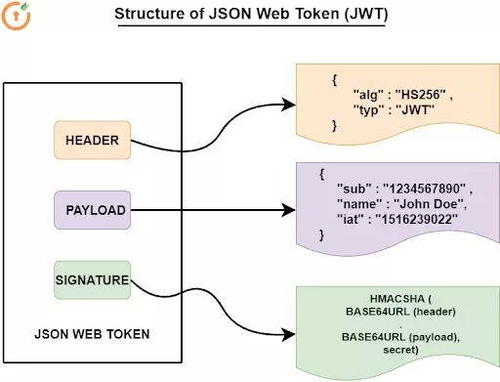

**Styles**

Styling of Entire Application is done using MaterialUI (MUI) for React.

Material UI is an open-source React component library that implements Google's Material Design.

It includes a comprehensive collection of prebuilt components that are ready for use in production right out of the box.

Material UI is beautiful by design and features a suite of customization options that make it easy to implement your own custom design system on top of our components.

1. **Itinerary Generator**: This Module is Entirely based on the Machine Learning Model, Embedded to the React Components in our Application.

Model will Ask users for Various Parameters like Budget, Time, Personalized choices of Places & Many more things.

Based on these parameters our ML model will Generate a Personalized itinerary for the user from source to destination considering Personalized Points of Interest of the user.

The Output of this Model will be Displayed by the React Application using React Hooks & Python Middleware API.



1. **Best Deals**: These Modules will be able to WebScrape all the Top Websites like TravelAdvisor, MakeMyTrip, Agoda, TravellersPoint for the Given Locations & Top Deals will be Fetched - Compared and Shown to the user using Node.js Web Scraping.

